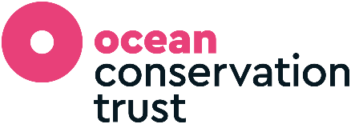
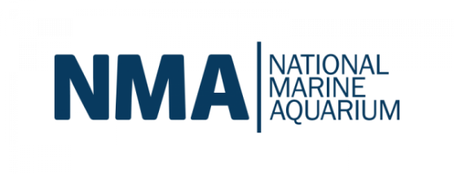
Husbandry Internship Programme Expression of Interest
At the NMA we believe that caring for complex aquatic ecosystems requires more than just labour, it requires a deep, intuitive understanding of biological signals and life-support systems. As a Husbandry Intern, you aren’t just an extra set of hands; you are a budding biologist being invited into the inner workings of our habitats. You will be working under the tutelage of our expert husbandry team to bridge the gap between classroom theory and the daily pulse of the water.
Please note that this role is a 3-month, full time placement including rota’d weekends (~37 ½ hours a week) for the following period: 26th May – 23rd August 2026.
Application Deadline: 22nd March 2026
Interviews: April 2026
The Internship
- Essential Maintenance: Assist in maintaining excellent hygiene standards of both displays and critical working areas.
- Biological Observation: Collaborate with the husbandry team to identify behavioural cues in wide array of species.
- Water Chemistry Mastery: Transition from testing water to interpreting data, learning how to adjust life-support parameters under expert guidance.
- Nutrition & Culturing: Develop precision in dietary preparation and live-feed culturing, understanding the "why" behind specific nutritional regimes.
- Systems Engineering: Assist in the maintenance of life support systems, gaining a foundational understanding of the "mechanical heart" of the aquarium.
- Peak Welfare: Assist with the continuous goal of achieving peak welfare, developing enrichment programmes, animal health plans, and habitat development.
What We Look For
- A foundational interest in marine biology or zoo science is essential, but we prioritize an eagerness to ask "why" and a desire for professional feedback.
- An understanding that husbandry is a physical, hands-on craft that requires attention to detail.
- We seek individuals who view mistakes as "teachable moments" rather than failures.

SECTION 1: APPLICANT PROFILE
Full Name:
Date of Birth:
Contact Info: Email:
Telephone:
Address:
Eligibility to work and live in the UK:
Current Academic/Professional Standing: (e.g., 2nd Year Marine Biology Student, Career Changer, Recent Graduate)
Animal Care Experience: (e.g. personal pets, home aquaria, research technician)
Previous Volunteering Experiences: (Any previous volunteer work performed in any sector)
Availability: Note: Our internship requires full working hours (0800-1600) to align with our Biologists schedules for the 13-week duration of the internship: 26th May – 23rd August 2026.

SECTION 2: PROFESSIONAL TRAJECTORY
In our internships, we focus on where you are going, not just where you have been.
1 What drew you to aquatic husbandry specifically? Is there a particular species or ecosystem that fuels your curiosity?

2. If you were to walk into our back-of-house area today, what is one system or task you would feel most "out of your depth" with? (e.g. LSS plumbing, fish health issues, water chemistry, maintenance tasks).

3. Is there an area/niche of aquatic husbandry that you have a particular interest in developing your skillset or gaining deeper experience in? (e.g. LSS management, aquatic veterinary, water chemistry, diving practices, enrichment & welfare, corals).

4. Where do you see your professional self in three years, and how would having a Biologist as a mentor change that trajectory?

SECTION 3: THE BIOLOGIST’S EYE
Husbandry is 10% action and 90% observation. We value your aptitude for detail.
4. Describe a time you noticed a subtle change in a biological environment (this could be a home aquarium, a houseplant, a pet, or a lab project). What did you see, and what was your "next step"?

5. Internships rely on a constant feedback loop. Tell us about a time you were given "course-correcting" feedback on a technical task. How did you process it and apply it?

SECTION 4: EXPECTATIONS & COMMITMENT
Husbandry is rewarding but physically demanding. Please acknowledge the following:
- Environmental: I am comfortable working in humid, wet, or loud environments. [YES/NO]
- Dietary Prep: I am comfortable handling raw seafood/diets for animal nutrition. [YES/NO]
- Physicality: I can perform the physical "heavy lifting" (e.g., salt bags, buckets) required to maintain a healthy ecosystem.
- [YES/NO]

SECTION 5: SUPPORTING DOCUMENTS
Please attach the following to your return email:
- [ ] Updated CV and cover letter (Focusing on your journey and interests)
- [ ] Optional: A portfolio or link to work/projects related to the natural world.

SECTION 6: ANCILLARY INFORMATION
We are committed to an inclusive recruitment process. If you require any reasonable adjustments to take part in the application or selection process, please let us know below.
You may also choose to share supplementary information about a disability, long-term health condition, or neurodivergence that may help us consider appropriate adjustments.
Providing this information is entirely optional and will not affect the assessment of your application. Any information shared will be handled sensitively and in line with relevant equality and data protection legislation.
Details (if applicable):

