
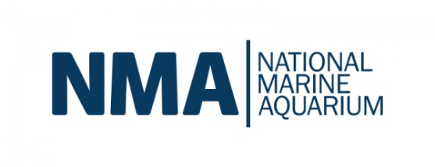
Husbandry Internship Programme Expression of Interest
At the NMA we believe that caring for complex aquatic ecosystems requires more than just labour, it requires a deep, intuitive understanding of biological signals and life-support systems. As a Husbandry Intern, you aren’t just an extra set of hands; you are a budding biologist being invited into the inner workings of our team. You will be working under the tutelage of our expert husbandry team to develop the skills and knowledge needed to succeed in this highly competitive industry.

Please note that this role is a 3-month, full time placement including rota’d weekends (~37 ½ hours a week) for the following period: 25th August- 22nd November
Application Deadline: 6th July
Interviews: Week commencing 13th July

Skills you will develop
- Essential Maintenance: assist in maintaining excellent hygiene standards of both displays and critical working areas.
- Biological Observation: collaborate with the husbandry team to identify behavioural cues in wide array of species.
- Water Chemistry: transition from testing water to interpreting data, learning how to adjust life support parameters under expert guidance.
- Nutrition & Culturing: develop skills in dietary preparation and live food culturing.
- Systems Engineering: assist in the maintenance of aquatic life support systems, gaining a foundational understanding of what it takes to keep an aquarium running.
- Animal Welfare: assist with maintaining our high standards of animal welfare by; developing enrichment programmes, animal health plans, and improving habitats.

What We Look For
- A genuine desire to work in animal care or conservation, particularly with aquatic species.
- A foundational interest in marine biology or zoological science is essential.
- An inquisitive nature and willingness to learn.
- An understanding that animal husbandry is a physical, hands-on craft that requires excellent attention to detail.
- An ability to take and learn from constructive criticism.

SECTION 1: APPLICANT PROFILE
Full Name:
Date of Birth:
Contact Info: Email:
Telephone:
Address:
Eligibility to work and live in the UK:
Current employment/ academic commitment: (e.g., 2nd Year Marine Biology Student, Career Changer, Recent Graduate)

Animal Care Experience: (e.g. personal pets, home aquaria, research technician)

Previous Volunteering Experiences: (Any previous volunteer work performed in any sector)

Availability: Note: Our internship requires full working hours (0800-1600) to align with our Biologists schedules for the 13-week duration of the internship: 26th May – 23rd August 2026.

SECTION 2: PROFESSIONAL TRAJECTORY
1 What drew you to aquatic husbandry specifically? Is there a particular species or ecosystem that fuels your curiosity?

2. Is there an area of aquatic husbandry that you have a particular interest in developing your experience of?

3. How do you hope that this internship will help with your professional development?

SECTION 3: EXPECTATIONS & COMMITMENT

Husbandry is rewarding but physically demanding. Please acknowledge the following:
- Environmental: I am comfortable working in humid, wet, or loud environments. [YES/NO]
- Dietary Prep: I am comfortable handling raw seafood/diets for animal nutrition. [YES/NO]
- Physicality: I am physically fit enough to work on my feet for extended periods of time.
- [YES/NO]

SECTION 4: SUPPORTING DOCUMENTS
Please attach the following to your return email:
- [ ] Current CV

SECTION 5: ANCILLARY INFORMATION
We are committed to an inclusive recruitment process. If you require any reasonable adjustments to take part in the application or selection process, please let us know below.
You may also choose to share supplementary information about a disability, long-term health condition, or neurodivergence that may help us consider appropriate adjustments.
Providing this information is entirely optional and will not affect the assessment of your application. Any information shared will be handled sensitively and in line with relevant equality and data protection legislation.
Details (if applicable):

