
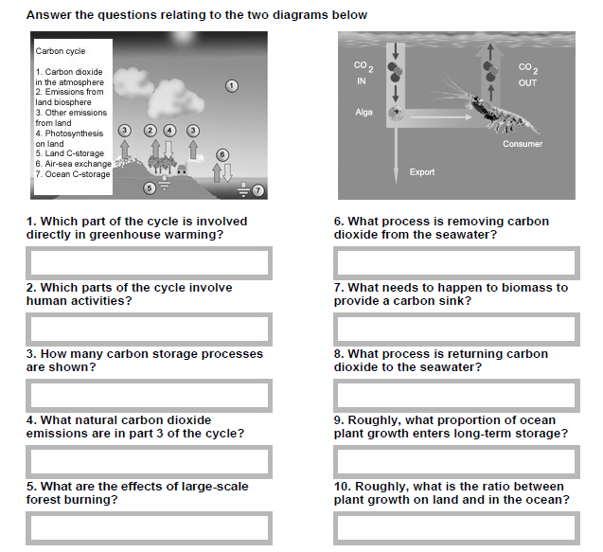

www.justaddh2o.tv
www.justaddh2o.tv

KS4 Carbon Cycle Worksheet
Name

Class

