
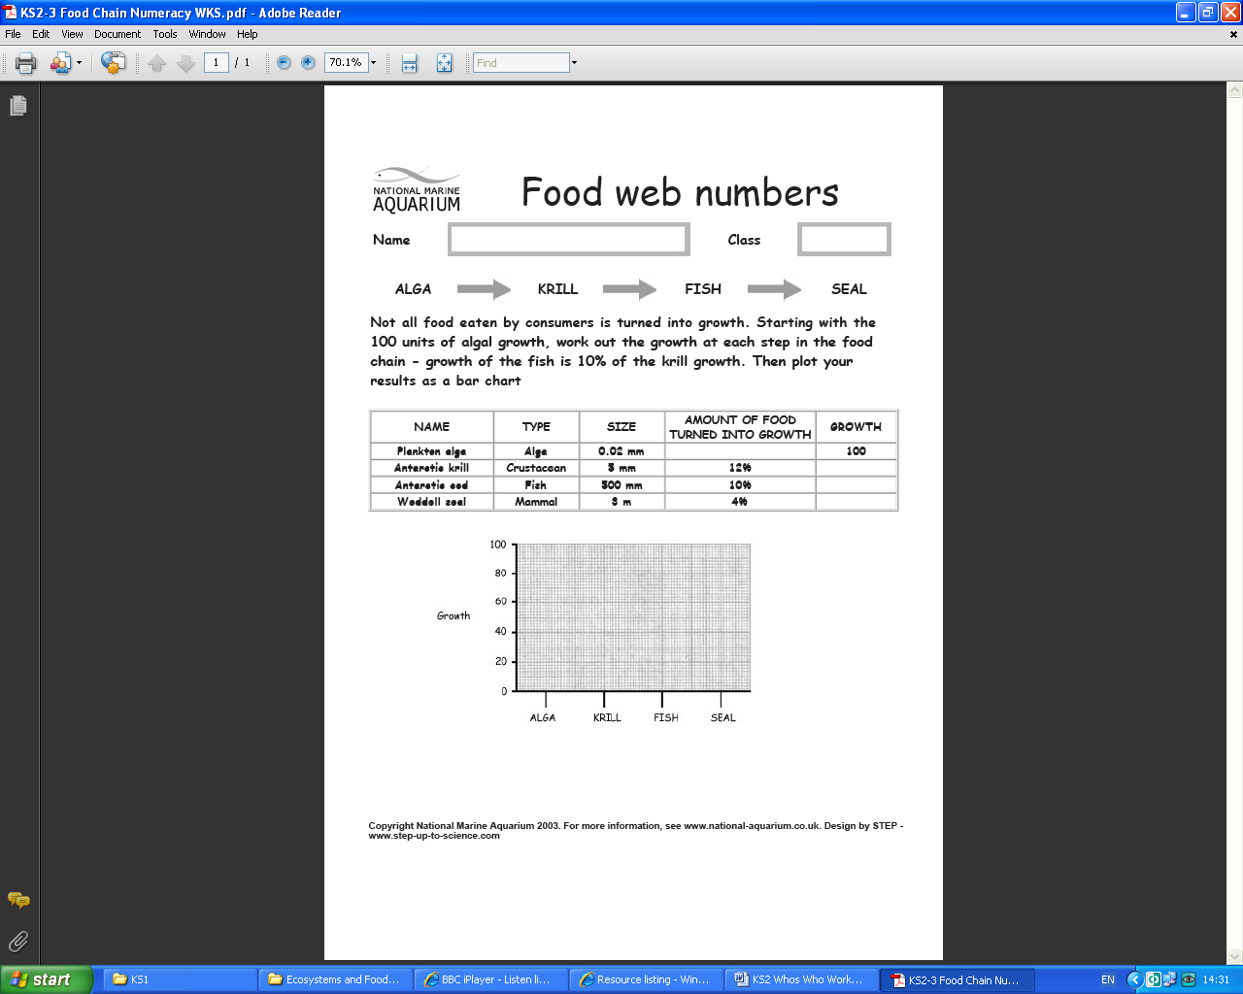

www.justaddh2o.tv
www.justaddh2o.tv

KS3 Food Chain Numbers Worksheet
Name

Class

