
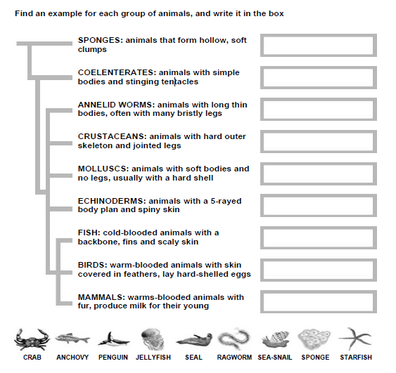

www.justaddh2o.tv
www.justaddh2o.tv

KS3 Classifying Animals Worksheet
Name

Class
CNIDERIA: animals with simple bodies and stinging tentacles
MOLLUSCS: animals with soft bodies and no legs, usually with a hard shell
FISH: cold-blooded animals with a backbone, fins and scaly skin
ECHINODERMS: animals with a 5-rayed body plan and spiny skin
CRUSTACEANS: animals with hard outer skeleton and jointed legs
ANNELID WORMS: animals with long thin bodies, often with many bristly legs
SPONGES: animals that form hollow, soft
clumps
BIRDS: warm-blooded animals with skin covered in feathers, lay hard-shelled eggs
MAMMALS: warm-blooded animals with fur, produce milk for their young

