
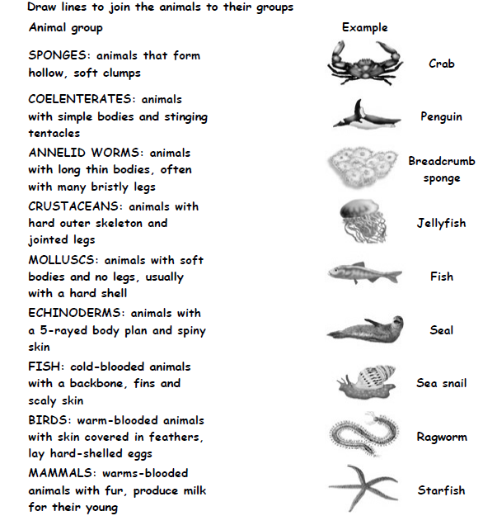

www.justaddh2o.tv
www.justaddh2o.tv

KS2 Who’s who Worksheet
Name

Class

