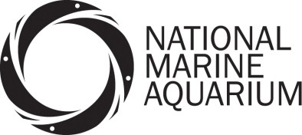
Communication Officer – Person Specification

Attributes | Essential | Desirable | How Identified
Education and Training | A degree (or equivalent) in Media Studies, Marketing, PR, Biological Science, English or other appropriate discipline. | Evidence of commitment to continuing professional development  Science communications | Interview  CV  Application form
Relevant Experience | 2 years in a similar role  Brand ambassador/champion experience  Professional social media account management  Campaign management  Adapting messages to different audiences  Press release drafting  Managing external PR agency relationships | Website content writing  Blog writing | Interview  CV  Application form
Special Knowledge and Skills | Excellent verbal and written communication skills  Good listener  Effective organisational skills particularly forward planning  Good knowledge of marine conservation  Good working knowledge of Microsoft office  Selling skills  Extreme attention to detail  Full clean driving license and car owner | Evaluation research experience  Personal interest in the marine environment  Adept at using marketing/design software  Budget management | Interview  CV  Application form
Personal Qualities | Self-motivated  Passionate about marine conservation  Energetic  Able to establish a rapport quickly with a wide variety of people  Resilience  Working to tight deadlines |  | Interview  CV  Application form

